Preview of table members before normalization:

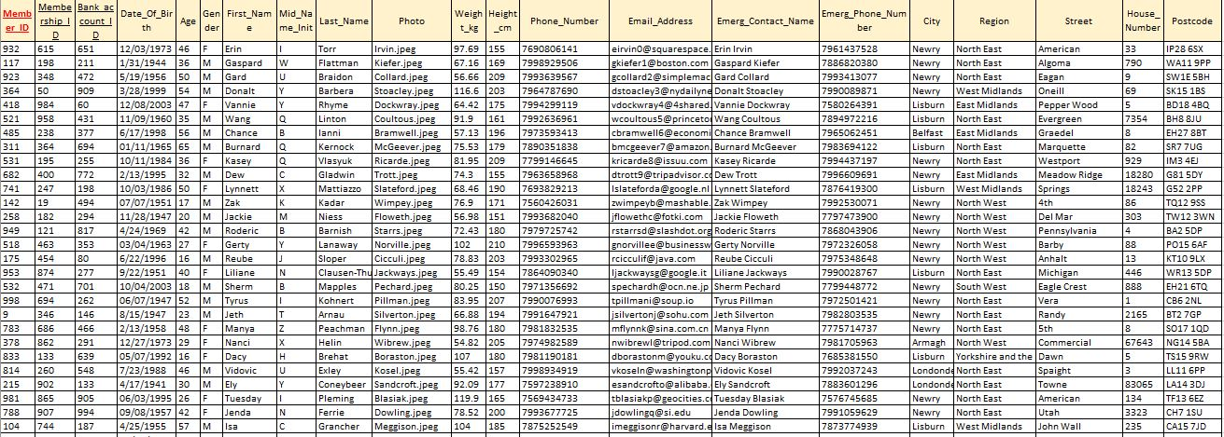

1NF

Entity is in 1NF.

PK is member_ID

FK’s are membership_ID, bank_account_ID.

2NF

Attributes city, region, street_name, house_number and postcode are not related to table members, so they will be moved in table member_addresses.

In table members will be create new attribute member_address_ID.

Member_address_ID will become FK.

3NF

Attribute age is transitive, by knowing date of birth it is possible to know age. This attribute don`t need to be stored in database.

Preview of members after normalization:

